**Install postfix and configure the Talend services to check its running or not.**

|  |  |  |
| --- | --- | --- |
| Signatures by each signatory indicate their acceptance that this document is complete and accurate to the best of his/her knowledge per responsibilities outlined in this document and as guided by approved methodologies and established procedures. | | |
| **Team Lead:**  **Artha Emp** | **Omkar** | **Date:** |
| **Project Manager:**  **Artha Emp** | **Pavan Valluri** | **Date:** |
| **Talend Developer:**  **Artha Emp** | **Omkar** | **Date:** |

 Step 1:- check the latest repository of postfix

rpm -qa | grep postfix

Step 2:- Install postfix on server.

yum install -y postfix

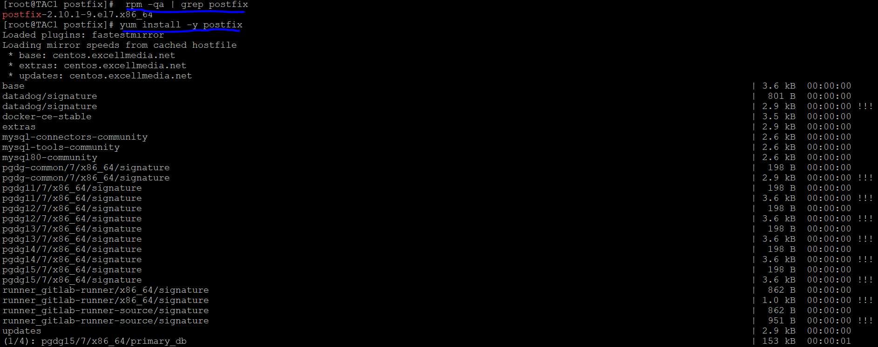

Step 3:-

systemctl start postfix

systemctl enable postfix

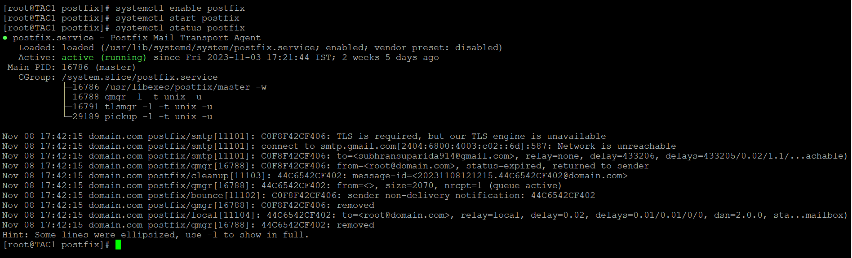

Step 4:- Change the Configuration setting

cd /etc/postfix

vi main.cf

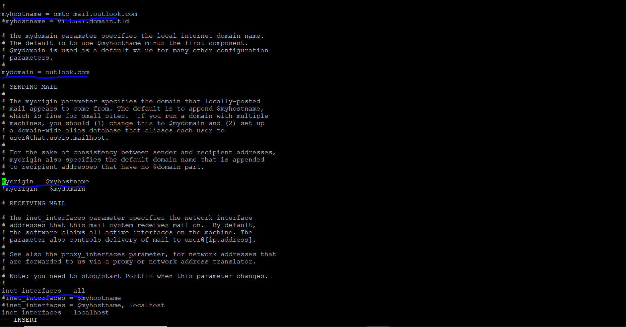 Step 5:-

yum install sendmail –y

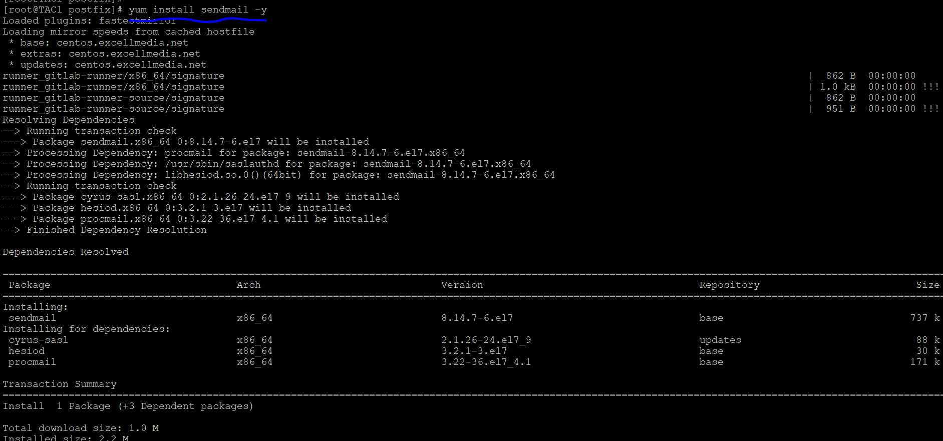

systemctl restart postfix

*Check by sending the mail

sendmail -s "Jai shree ram" omkar.patil@thinkartha.com

(if it’s working then configure the script)

Step 6:- Generate the shell script

cd /opt

vi alert.sh

#!/bin/bash

# Define the service name

SERVICE_NAME="talend-tac-8.0.1.service"

# Check the service status

if systemctl is-active --quiet $SERVICE_NAME; then

# Service is running

echo "$SERVICE_NAME is running."

else

# Service is not running

echo "$SERVICE_NAME is not running. Sending email notification."

# Define email parameters

TO="recipient@example.com"

SUBJECT="$SERVICE_NAME is down"

BODY="The $SERVICE_NAME service is not running on the system."

# Send the email notification (you may need to configure your email tool)

echo "$BODY" | mail -s "$SUBJECT" $TO

fi

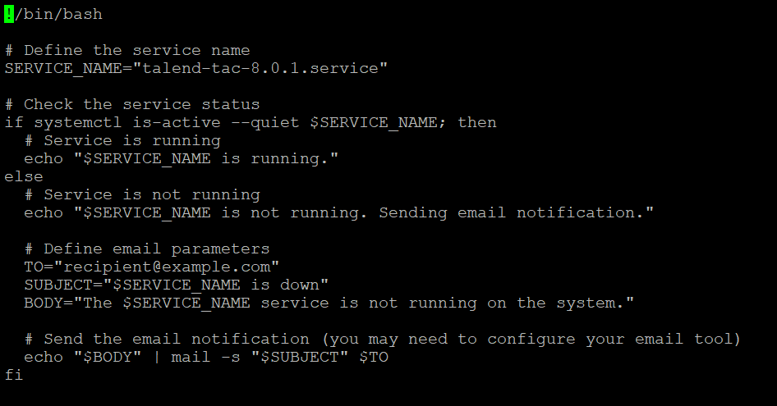

chmod –R 777 alert.sh



Step 7:- Add the script path to crontab

crontab –e

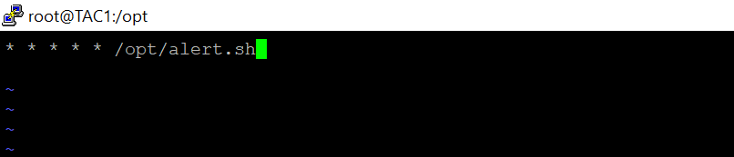

<https://www.redhat.com/sysadmin/install-configure-postfix>